

Clinical Information Pack

Post title: Principal Teaching Fellow in Public Health
Date last updated/evaluated: December 2025
Author: Emma Plugge
Standard Occupation Code: 2311 (visit Occupation Codes to help identify a SOC code)
School / Department: Primary Care, Population Sciences and Medical Education
Faculty / Directorate: Faculty of Medicine
Job Family: Clinical
Clinical Category: Academic Teach
Grade: Consultant
Salary: £109,725 - £145,478
Post reporting to: Professor of Public Health
Post line report(s): N/A
Post base location: Hybrid: Campus / Home : as agreed with line manager

Particulars of Appointment
The Faculty of Medicine, supported by University Hospital Southampton NHS Foundation Trust wishes to appoint a Principal Teaching Fellow in Public Health.

This academic post is based within the Department of Population Sciences, part of the School of Primary Care, Population Sciences and Medical Education and based at University Hospital Southampton. You will be an experienced public health consultant, who holds a substantive Consultant post within a local authority public health team in Hampshire (this includes Portsmouth and Southampton). You will lead on improving employability for our students and increasing opportunities for them to experience working in local authority settings in Hampshire. You will lead on establishing teaching links between PPM and local authority public health and local UKHSA HPTs to ensure that the MPH is relevant to local and national public practice. This will include leading the dissertation module. You may also contribute to the delivery of teaching to undergraduate medical students.

The University of Southampton
The University of Southampton is a leading research-intensive University, a member of the Russell Group and one of the top 100 universities worldwide. We deliver an excellent educational experience, world-leading research and we are known for successfully commercialising that research through enterprise.

This is an exciting time to join the University of Southampton. We have an aspirational University Strategy (see www.southampton.ac.uk/strategy), setting out our ambitions over the next five years. The strategy involves achieving a top 10 place in the UK for research, which we will achieve by investing in the highest quality staff and facilities. We are also transforming the education offer available to undergraduate and postgraduate students across the University, providing greater flexibility and modular courses, with a strong international focus.

The Faculty of Medicine
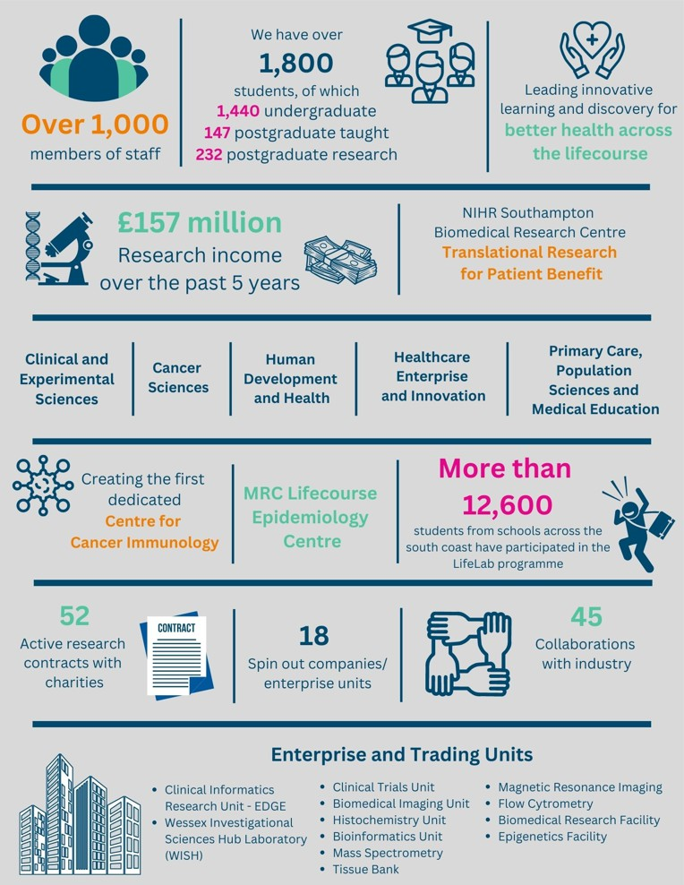

The creation of the Faculty of Medicine has enabled us to build upon strong foundations of basic research and clinical translation. Working with colleagues across the University and in the local NHS we have strengthened our position as a renowned centre for translational research, leading innovative learning and discovery for better health across the life-course

Key to the success of the Faculty of Medicine is the delivery of high-quality education for undergraduate and postgraduate students, building on our partnerships across the University and University Hospital Southampton NHS Foundation Trust and fostering new collaborations with local authority public health teams in Hampshire. The post holder will play a key role in these developments.

The Faculty celebrated its 40th anniversary in 2016. In 1971 FoM consisted of 40 students. FoM is now reputed for its excellence in research, innovative clinical teaching and is a vibrant pillar of the South of England community.

The Student Experience

We offer a range of undergraduate programmes: the BM4 programme, a graduate-entry four-year programme which accepts 40 students per year; and the BM5and BMedSc programme which accepts 200 students per year including approximately 30 students from a BM6 programme aimed at widening access to a medical career. Science teaching in the first three years of the BM programmes is delivered in the South Block of Southampton General Hospital as well as the Life Sciences Building on Highfield Campus. Clinical teaching takes place at Southampton General Hospital and the adjoining Princess Anne Hospital, the Royal South Hants Hospital, and in NHS Trusts and General Practices throughout Hampshire, Dorset, West Sussex and Salisbury.

The BM5 programme has a number of distinctive features. These include the integrated nature of teaching where the scientific disciplines are taught together in a clinical context using a systems-based approach and the BMedSc programme, an eight-month supervised research project undertaken in Year 4. There is also the opportunity, for selected students, to undertake an integrated, intercalated Masters in Medical Science (MMedSc). The BM4 programme also has a number of key features. These include clinical topics in the first two years where students meet on a regular basis in Graduate Groups and learning with BM5 students in the third and fourth years on all clinical attachments. All students take the same intermediate and final examinations. All programmes have substantial clinical experience in the first two years, student selected components, dispersed final year attachments, work shadowing prior to commencing a Foundation post and inter-professional learning.
In addition to the undergraduate BM programmes the School provides Masters Degree programmes in Public Health and Allergy, Diabetes and Genomics.

Research and Enterprise
The Faculty of Medicine has a clear research strategy to investigate the biomedical basis of common human diseases and to translate this into clinical practice. All research undertaken within the Faculty has clear evidence of international excellence and is delivered through appropriate Faculty Schools.

The Faculty of Medicine Enterprise Strategy is fully aligned to the University Enterprise Strategy to provide a step change to its enterprise and innovation culture, delivering global outreach, community engagement, innovative healthcare and policy. We work with all stakeholders from industry and pharma to health providers and the community.

Equality, Diversity and Inclusivity
We are committed to positively advancing equality of opportunity. We participate in a number of equality initiatives which celebrate good employment practice for the advancement of diversity, equality and inclusivity. These include the Stonewall Workplace Equality Index, the Race Equality Charter and Athena Swan, (for which we are currently silver award holders). We also have a number of staff equality committees who champion the advancement of equalities for diverse groups.


Southampton Behaviours
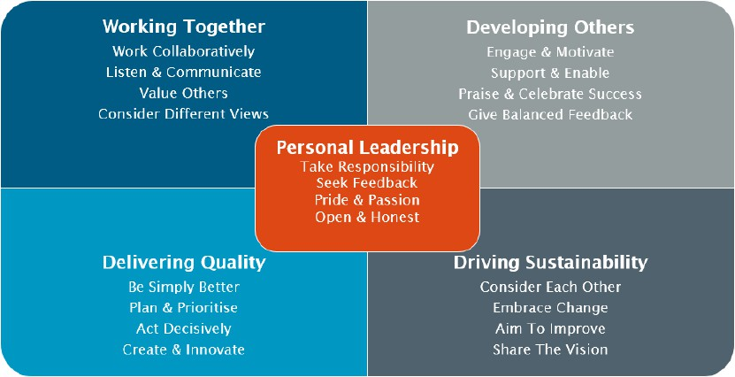

School Information
Primary Care, Population Sciences and Medical Education (PPM) is one of the five Schools in the Faculty of Medicine (Head Professor Nick Francis).

This School encompasses a wide range of academic disciplines for applied health research: clinical primary care and public health; epidemiology; medical statistics, qualitative methods, health economics, and health psychology. There is a single management and administrative structure with bi-monthly team meetings of all senior academic staff, responsible for policy, strategic planning, and research oversight with strategic Away Days. We have strong research collaborations with relevant clinical disciplines in the Faculty of Medicine and methodologists and clinicians in other Faculties, (notably in Psychology, Medical Sociology, Statistics, Nursing and Health Geography). There are sixteen senior academics in PCPS (nine professors, seven associate professors), 18 post docs and 13 PhD/MD students and a total staff footprint of around 80. We promote the equality and diversity agenda which is a standing item at Unit and Faculty Leadership Team meetings, and are planning to improve from silver award to gold award.

Research funding currently totals about £10 million from a diverse range of sources (NIHR programmes HTA, EME, PGfAR, RfPB, EME, HSR, and PHR, School of Primary Care Research (SPCR), as well as charitable (ARC, BHF) and industry (Pukka). The School currently leads five prestigious NIHR Programmes and provides major contributions as Work-package leaders to three others. The Unit’s research has focused broadly on:
- Managing common conditions in primary care, with the aim of preventing inappropriate use of antibiotics in infectious disorders and the inappropriate use of antidepressants in mental health disorders
- The epidemiology prevention and management of key chronic diseases (eg chronic kidney, liver and respiratory diseases) and multimorbidity, particularly the promotion of self- management using digital technology to avoid medicalisation and iatrogenesis;
- Addressing vulnerable groups: Mental Health, Health inequalities, HIV/sexual health, Older age (cognitive decline and malnutrition), and maternal/child health.
- Understanding and enhancing communication in consultations, and improving the evidence base for integrative medicine

There is active use of large databases (CPRD, Hampshire Health Record) (HHR)) and there is strong methodological input in medical statistics, health economics and qualitative methods.

PCPS includes the Primary Care group, the Population Health Sciences group (Nisreen Alwan), Medical Statistics research group (Scott Harris), and the NIHR Research Design Service (RDS) South Central (Isabel Reading).

In the 2014 REF exercise 87% of our research was rated as ‘internationally excellent’ or ‘world-leading’. In UoA2, we ranked 3rd highest of 32 HEIs for the quality of our outputs. UoA1 the Faculty was eight of all medical schools in power weighted index.

PhD support and training. All students PhD students are allocated a desk and IT support. They are provided with a laptop by the University IT support (iSolutions), set up for access to the shared drives and all the IT and library resources support that the University provides. Students also benefit from support from the administrative structures of the Academic Unit/University, including appropriate access to secretarial support and human resources. Access to the internet is available throughout the Academic Unit. Senior PCPS academics provide individual mentorship to early career researchers (ECRs), which is complementary to the Faculty-wide mentorship scheme. A senior staff member is responsible for postgraduate development within the Unit. To enhance the career development and research excellence of ECRs in PCPS we set up the Research Education Advice and Communication in Health (REACH) forum, which includes all doctoral and postdoctoral students and fellows, and contract researchers. They meet regularly to present research ideas and findings and to discuss issues of common concern and there is REACH representation on the Senior Management Team (SMT). The Unit also hold an annual PhD day at which all our PGRs present.
PhD training involves both formal and informal processes. All our PhD supervisors must attend the University supervisor training. The Faculty Graduate School Programme provides generic support (developing skills in ethics, presentations, statistics, Good Clinical Practice, etc). Many of our PhD students have completed an MSc involving research methods and training is individualised depending on the needs of the PhD which often involves specific specialist courses outside the department (e.g. qualitative methods in the Faculty of Health Sciences; Courses in Applied Social Surveys in S3RI; the MSc in Primary Care Research Methods in Manchester; and short courses e.g. the London School of Hygiene course in Advanced Epidemiology). Supervisors meet regularly with students to review progress and are required to submit formal reports to the Faculty at 5 and 11 months and an internal transfer viva at about 18 months. Sixteen students in Primary care were awarded doctorates during the period 2012-2017 inclusively, five of whom went on to postdoctoral posts and two returned to clinical posts

Public Health Group – Senior Staff at Southampton Head: Professor Nisreen Alwan
Professor Nisreen Alwan Professor Adam Briggs Professor Simon Fraser
Professor Kalyanaraman Kumaran
Professor Nuala McGrath
Professor Julie Parkes
Professor Emma Plugge
Associate Professor Sara Morgan
Associate Professor Kate Glyn-Owen

University Hospital Southampton NHS Foundation Trust (UHS)
University Hospital Southampton NHS Foundation Trust provides services to some 1.9 million people living in Southampton and south Hampshire, plus specialist services such as neurosciences, cardiac services and children's intensive care to more than 3.7 million people in central southern England and the Channel Islands.
The Trust is also a major centre for teaching and research in association with the University of Southampton and partners including the Medical Research Council and Wellcome Trust. UHS gained Foundation Trust status on 1 October 2011.

Every year 11,500 UHS staff:
- treat around 150,000 inpatients and day patients, including about 50,000 emergency admissions;
- see over 624,000 people at outpatient appointments; and
- deal with around 135,000 cases in there emergency department.
Providing these services costs £1.9 million a day.

Job purpose: Education: This academic post is based within the Department of Population Sciences, part of the School of Primary Care, Population Sciences and Medical Education. The postholder will lead on establishing teaching links between PPM and local authority public health and local UKHSA Health Protection Teams to ensure that the MPH is relevant to local and national public practice. You will also contribute to the delivery of teaching, co-leading two taught modules on the MPH.

Key accountabilities and indicative time allocation:
- 80%
Education Contribution:
- Grow a reputation, within and beyond the University, for excellence and enhancement in scholarly education activities, founded on high-quality educational delivery and scholarship of education.
- Manage, develop and deliver education activities of a consistently high standard across a range of modules.
- Lead in the development of education approaches that embed educational best practice and enhancement, including through inclusive and flexible teaching practices and the use of new technologies.
- Contribute to development of materials, delivery of teaching, marking and assessments for MPH. This will include:
  - Co-leading the Foundations in Public Health and Dissertation modules (includes sourcing project supervisors and markers from across UoS, UHS, LAPH and UKHSA HPTs, agreeing project scope, providing support and training to supervisors and markers, delivery of tutorials throughout module, organising end of module conference, arranging DSAs with relevant organisations for projects, support students throughout)
  - Contributing to the PDS module
  - Reviewing a proportion of annual applicants
  - Leading internship/work experience opportunities for MSc students
- To lead on the development of teaching links between PPM and local authorities and local UKHSA HPTs. This might include recruiting speakers from LAs and beyond for relevant modules and speakers for career sessions. It should also include work with LAs and HPTs to understand their requirements for the local public health workforce for the MPH and so inform curriculum development.
- 15%
Leadership, Management and Engagement Contribution:
- Successfully undertake management, engagement and administrative roles within the department, School or Faculty.
- Manage and develop significant processes and co-ordinate the work of others. Determine priorities, set objectives and quality standards and manage the resources (people, funding, infrastructure etc.) needed to deliver planned objectives and requirements.
- Represent and promote the work and impact of the School, Faculty and/or University within and beyond the University.
- Organise and/or participate in visit days, open days and public engagement activities.
- Negotiate effectively on behalf of PPM on key issues.
- 5%
Any other duties as allocated by the line manager following consultation with the post holder.

Internal and external relationships:
Senior colleagues in School of PPM, research fellows and students, administrators.
Academics in Faculty and wider university, academic collaborators clinicians at University Hospital Southampton Trust and elsewhere, public health professionals in Local Authorities, OHID, ICBs, UKHSA and in the wider health and care system, public health specialist trainees, health service professionals, administrators, research funders, peer reviewers and editors involved in the programme of research.

Special requirements:
Must be a public health consultant who is currently employed by one of the local authority public health teams or UKHSA teams across Hampshire, including Southampton and Portsmouth.

Person Specification – Skills and Competencies
All essential and desirable criteria outlined in this Person Specification will be assessed through a combination of recruitment application and CV, and where applicable numerical or written assessment.
Knowledge, Experience and Qualifications
Essential
- Degree in health-related discipline or medical qualification (MBBS or equivalent)
- Inclusion on the GMC specialist register as a Public Health specialist/UKPHR public health specialist register/GDC specialist list or equivalent.
- MFPH or equivalent
- Certificate of completed specialist training (or equivalent)
- Wide knowledge and demonstrable skills in public health across Hampshire
- Track record of teaching.
- Current employment at consultant level by a local authority or UKHSA Health Protection Team in Hampshire, including Southampton and Portsmouth.

Desirable
- Teaching qualification (PGCAP or equivalent).
- Membership of Higher Education Academy.

Teamwork and Communication
Essential
- Work effectively in a team, understanding the strengths and weaknesses of others to help teamwork development
- Fosters and maintains working relationships within and beyond the University.
- Proactively works with senior managers across the University to achieve work outcomes.
- Negotiates effectively on behalf of the department or University to achieve work outcomes.
- Uses influence and persuasion to positively develop and agree long-term priorities and strategic plans.
Desirable
- Able to engage counselling skills and pastoral care, where appropriate

Planning, Organisation and Resource Management
Essential
- Plans and manages major new projects or work activities, where precedent may not exist, ensuring plans complement wider strategic plans.
Desirable
- Proven ability in the design of course units, curriculum development and new teaching approaches.
Problem Solving and Initiative
Essential
- Demonstrates authoritative awareness of the theories and practices of a specialist field, and an ability to apply this to achieve work outcomes and resolve novel, deep-rooted or highly complex problems.
- Develops significant new concepts and original ideas within a specialist field to address issues of strategic importance.
Job Hazard Assessment
A full health clearance is required for this role where any hazards marked “^”, using the agreed Occupational Health referral template available from here. Where a full health clearance is required, this will apply to all role holders, including existing members of staff.

Physical Environment
Working outside ^ Not applicable
Exposure to noise levels >80dbA ^ Not applicable
Working with dust or fumes ^ Not applicable
Working with skin irritants ^ Not applicable
Working with chemicals (industrial or cleaning) ^ Not applicable
Working in a confined space ^ Not applicable
Working at height ^ Not applicable
Working with sewage ^ Not applicable
Contact with cytotoxins ^ Not applicable
Exposure Prone Procedure (EPP) work ^ Not applicable
Contact with clinical specimens or pathology work ^ Not applicable
Direct patient care or patient contact Not applicable
Exposure to temperature extremes Not applicable
Frequent hand washing Not applicable
Ionising radiation Not applicable

Psychological and Social Environment
Working shifts ^ Not applicable
Working nights ^ Not applicable
Lone working Not applicable
Working with children Not applicable
Exposure to persons with challenging behaviour Not applicable
Working with larger groups Occasionally <30% Time

Equipment, Tools and Machines
Working with vibrating machinery or tools ^ Not applicable
Driving duties e.g. LGV, PCVs, forklift trucks ^ Not applicable
Food handling Not applicable
Contact with latex Not applicable

Physical Abilities
Prolonged physical movements or actions e.g. walking ^ Not applicable
Prolonged Standing or Sitting ^ Not applicable
Moving or handling heavy loads ^ Not applicable
Repetitive pulling or pushing ^ Not applicable
Repetitive climbing (steps, stools, ladders, stairs) ^ Not applicable
Repetitive crouching, kneeling or stooping Not applicable
Repetitive lifting Not applicable
Fine motor grips (e.g. pipetting) Not applicable
Repetitive reaching below shoulder height Not applicable
Repetitive reaching at shoulder height Not applicable
Repetitive reaching above shoulder height Not applicable

